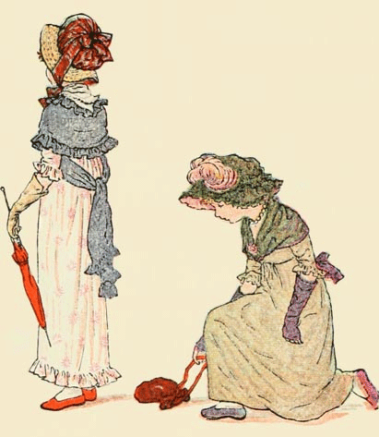
Pockets, Pouches & Secret Drawers

A VIRTUAL CONFERENCE
held on zoom by the IMLR, University of London

Thursday 2 - Saturday 4 December 2021

EARLY-CAREER BURSARY FORM

We are pleased to offer a number of Early-Career Bursaries to support attendance at this conference.
The deadline for application, using this form, is 6 October 2021. You do not need to be giving a paper at the conference to be considered for a bursary, but you do need to be in early career.
The definition of ‘early-career’ includes postgraduates & academics up to 10 years after completion of the PhD, and artists in the first 10 years of their creative activity.

The application form is below: please fill it in electronically and send it as an attachment to
Naomi Segal (naomi.segal@sas.ac.uk) and Anna Jamieson (ajamie01@mail.bbk.ac.uk).

A bursary consists of a fee-waiver. The conference fees are:
STANDARD: £30 | STUDENT/UNWAGED: £15

Your surname

Your first name

Institutional affiliation, if applicable
Email address
Title of your conference paper (if applicable)

Your field of interest

Case for support (max 300 words). Please explain the following:

- Your interest in the topic of the conference and what you can contribute

- your case for receiving a bursary

Your webpage (if applicable)
I confirm that all the information provided in this form is complete & accurate (please tick or e-sign)

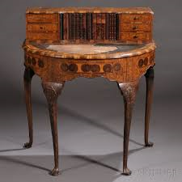

For all details of Pockets, Pouches & Secret Drawers, see
https://modernlanguages.sas.ac.uk/events/event/22520

or email Naomi Segal or Anna Jamieson

