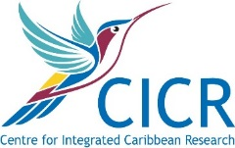
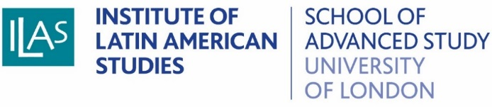
Postgraduate Training Day:
Conducting Fieldwork in Latin America and the Caribbean

16/02/2018, Senate House, Room G22/26

Cost: £10 (lunch and coffee included)

This one day training event is for postgraduate students embarking on fieldwork in Latin America and the Caribbean. Hosted by the Institute of Latin American Studies, the event features experienced researchers from diverse disciplinary backgrounds. The event will introduce students to a range of strategies and techniques to design and execute their future research trips effectively, will prepare students for challenges they may encounter in the field, and will provide them with the opportunity to discuss their plans with experienced researchers. A small charge of £10 will cover the cost of catering.

Registration is essential. Please sign up at:
https://ilas.sas.ac.uk/events/event/14752

Programme:

10.00-10.15 Welcome and Introductions
Prof Linda Newson (ILAS Director) and Dr Niall Geraghty (ILAS)

10.15-11.00 Exploring Latin American Archives
Prof Linda Newson (ILAS)

11.00-11.15 Coffee

11.15-12.00 The Seven C’s of Interviewing
Dr Asa Cusack (LSE)

12.00-12.45 Working in Collaboration with Latin American Partners
Dr Mark Thurner (ILAS)

12.45-13.30 Lunch

13.30-14.15 What do we do when we do Ethnography?
Dr William Tantam (ILAS) and Dr Ainhoa Montoya (ILAS)

14.15-15.00 Dealing with Challenges in the Field
Dr Chandra Morrison (LSE)

15.00-15.15 Coffee

15.15-16.00 It’s All Been Relevant: Fieldwork in Literature, Cinema and the Arts (and a general summary)
Dr Niall Geraghty (ILAS)

16.00-16.30 General Q + A

