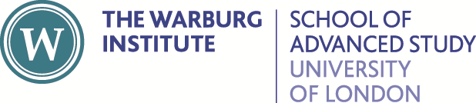

Of Honey, Heaven Sent. An Illustrated History of Bees

Tuesdays & Thursdays, 18 & 20, 25 & 27 July 2023
An online short course, with Dr Laura Popoviciu (UK Government Art Collection)

Application for a bursary
Bursaries cover a full fee waiver and are awarded on a competitive basis. Please complete the form below and return together with a brief (1 page) CV.

Name:

Email:

Correspondence address:

University affiliation (if any):

Current course of study (if any):
BA / undergraduate
MA / postgraduate
PhD / postgraduate research
Freelance / unwaged
Please outline why you wish to enrol on this course and why you need the bursary in order to do so (300 words max):

Please return the completed form with supplementary documents by 5.00pm Friday 23 June 2023 to: Jon Millington, Academic Impact and Engagement, Warburg Institute, Woburn Square, London WC1H 0AB; or email to: SAS.Events@sas.ac.uk

